The Key to Scalable Quantum Networks

21K-3153

1. The speaker gave an overview of the basics of quantum mechanics and its applications in quantum computing, such as superposition and entanglement.
2. The role of qubits was explained, including why they need to be kept ultra-cold. The **heat** **generated by a measurement destroys the superposition of the qubit**, thus making it collapse into one state. For qubits to obey laws of superposition, they need to be kept in extremely cold areas.
3. Classical gates and their quantum counterparts were shown, such a the Pauli-X gate, Hadamard gate and more.
4. The concept of entanglement was explained and then the question arose as to how entanglement could be extended across various locations. The answer was “entanglement swapping.” Alice has Qubit 1. Bob has Qubit 2. Both want their qubits to be entangled, but not directly. A third person, Charlie, has 2 qubits. His first qubit is entangled with Alice's. His second qubit is entangled with Bob's. And then he entangles both his qubits together. This indirectly entangles Alice’s and Bob’s qubits. This could be useful in building scalable quantum networks in the future. The role of “Charlie” can be given to **repeaters** which could extend quantum connections.

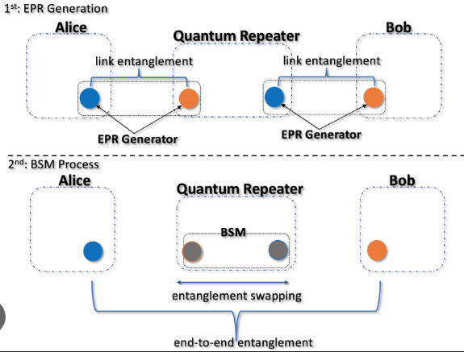

1. An electron with no spin can be split into 2 electrons with equal but opposite spins. This is useful when understanding how “spin-qubits” work, where the quantum state is determined by the spin of an electron (typically spin-up or spin-down), and could also be useful in entanglement.

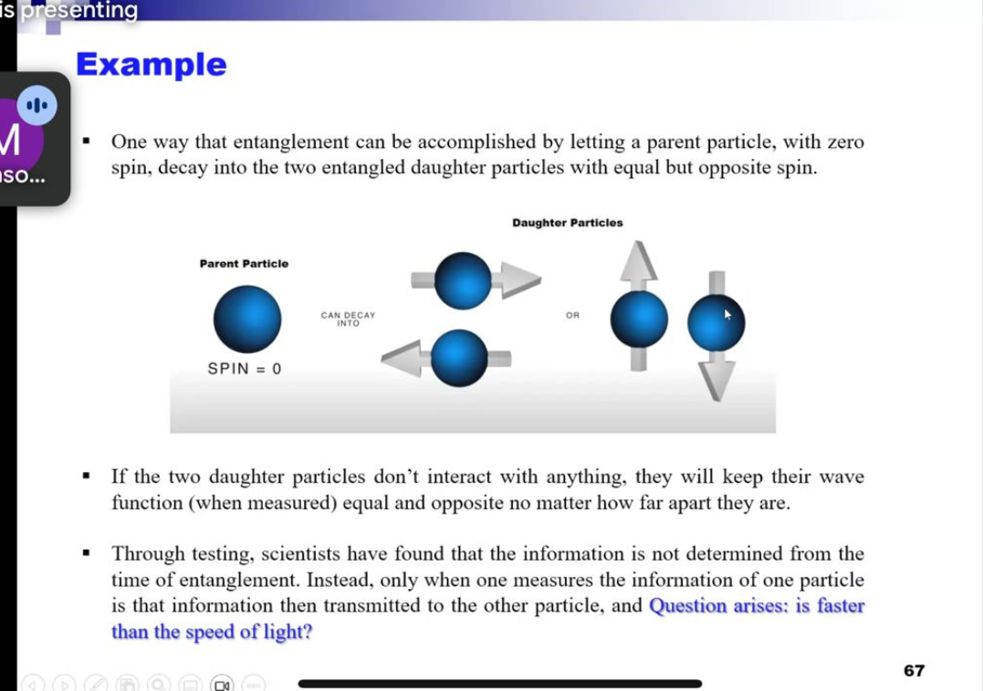

1. Real life quantum algorithms were discussed, including Grover’s Algorithm for database searching and Shor’s algorithm was cracking cryptography. Shor’s algorithm’s efficiency in cracking RSA was highlighted.
2. In the end, a possible future internet network based on Quantum Computing was discussed. It was outlined that quantum computing will not replace classical computing, but exist in harmony with it, allowing for better efficiency across all platforms.

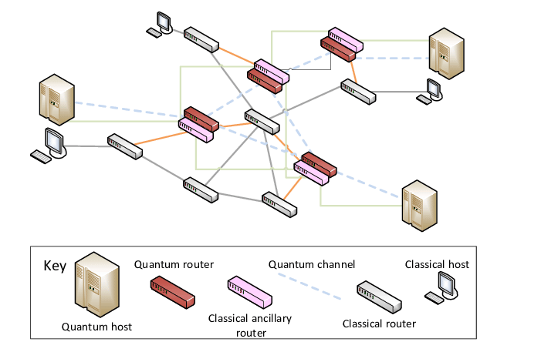

1. Current companies working on quantum computing were highlighted, which included Google, Qiskit and IBM.
2. Resources for students to practice making quantum circuits were given. The resources were: [Algassert](https://algassert.com/quirk) and [IBM](quantum.ibm.com/composer) Circuit Composer.